NEWS RELEASE Editorial Contact:
For Immediate Release Dennis Phillips (970) 576-3251
dphillips@steiner-optics.com

New Steiner GS3 Game Sensing Riflescopes
With 5x Zoom Range

GREELEY, Colo. (Jan. 2014) —The new Steiner GS3 “game sensing” scope utilizes the unique CAT™ Color Adjusted Transmission lens coatings to amplify contrast in the peak human vision sensitivity range. The optimized contrast effectively separates game from leafy or shadow-dappled backgrounds, exposing targets for a clean, accurate shot. The GS3 5x zoom range lets hunters from Eastern whitetail country to Western big game ranges pair their new scope with their favorite centerfire, rimfire or muzzleloader rifle. All combined with Steiner’s bedrock combat-reliability for unfailing performance.

Available in four models — 2-10x42mm, 3-15x50mm, 3-15x56mm and 4-20x-50mm —that offers a viable solution for any shooting or hunting situation. They are ruggedly built to be waterproof, shockproof and durable enough to last for generations.

Steiner equips all version of the GS3 scopes with its exclusive Plex S2 etched reticle. The Steiner Plex S2 provides a simple, uncluttered method for determining both trajectory and wind compensation. The reticle presents a series of cascading .25 MOA dots that help calculate drift to compensate for crosswinds. The dots represent bullet drift from a 10 mph crosswind (+/-1.5 inches at 400 yards) for a wide variety of hunting cartridges.

The GS3 4-20x50 model features side parallax adjustment and is available with both the Plex S2 and the Plex S7 reticles. The Plex S7 reticle makes trajectory compensation simple with hash marks calibrated to provide dead-on aiming from 100 to 500 yards for many of the most common hunting cartridges. The Plex S7 reticle replaces the cascading dots with lines that indicate windage drift for either 5 or 10 mph.

As with all Steiner optics, the GS3 line of riflescopes is covered by the industry-leading Steiner Heritage™ Warranty. Steiner is committed to the very highest standards of quality, dependability, and most of all customer satisfaction. The Steiner Heritage™ Warranty assures you of that commitment.

Other GS3 riflescope features include:
- Versatile mounting length of just 5.4 inches for mounting on short actions, muzzleloaders, or lightweight mountain rifles.
- Ergonomically designed, large turret knobs and a power ring with deep knurling make removal and adjustments almost effortless.

—More—

- Turrets with ¼-MOA adjustments for both windage and elevation. The turrets can also be reset to “0” once you’re sighted in.
- Rugged 30mm tube milled from solid aluminum stock so there are no welds or seams, for greater strength and durability.
- Side Parallax Adjustment/Focus on the 4-20x50mm model.

They will be available at retailers nationwide in the spring of 2014.

Steiner GS3 Riflescope Specifications

Item No. | GS3 Riflescope | Field of View  (ft. @ 100 yd.) | Exit Pupil (mm) | Click Value @ 100 yd. | Elevation Adjustment @ 100 yd. | Windage Adjustment @ 100 yd. | Eye Relief (In.) |  | Length (in.) | Weight (oz.) | MSRP
5004 | 2-10x-42mm | 52 low – 10.5 high | 12 low – 4.2 high | 1/4 MOA | 70 MOA | 70 MOA |  | 3.5 – 4.25 | 13.5 | 18 | $919.99
5005 | 3-15x-50mm | 36 low – 7.5 high | 11 low – 3.5 high | 1/4 MOA | 70 MOA | 70 MOA |  | 3.5 – 4.25 | 14.4 | 23 | $1,029.99
5006 | 3-15x-56mm | 36 low – 7.5 high | 11 low – 3.7 high | 1/4 MOA | 70 MOA | 70 MOA |  | 3.5 – 4.25 | 14.1 | 24 | $1,029.99
5007 | 4-20x-50mm | 25.8 low – 5.5 high | 11 low – 2.5 high | 1/4 MOA | 64 MOA | 48 MOA |  | 3.5 – 4.25 | 14.9 | 22 | $1,149.99
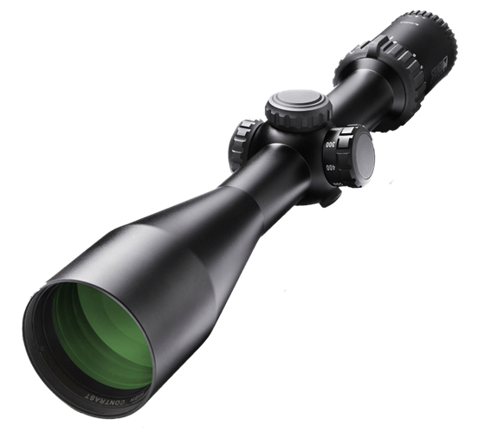

Headquartered in Germany, Steiner-Optik has been widely acknowledged as a world leader in the manufacturing of high quality optics since 1947. In addition to the outdoor, hunting and marine markets, Steiner provides products to military and law enforcement worldwide. Allied forces around the world — including the U.S. Army and countless law enforcement agencies — have made Steiner their optics of choice. For more information, contact: Steiner-Optik, 920 54th Avenue, Suite 200, Greeley, CO 80634; call (970) 356-1670 or toll free (888) 228-7747. Visit the company website at www.steiner-optics.com or Facebook page at www.facebook.com/SteinerOptics.

