

NEWS RELEASE Editorial Contact:
For Immediate Release Dennis Phillips (970) 576-3251
dphillips@steiner-optics.com

New Nighthunter Xtreme 8x56 Binocular Delivers
Industry’s Best Light Transmission

GREELEY, Colo. (Jan. 2014) — The new Nighthunter Xtreme 8x56 porro prism binocular delivers images that are remarkably bright in low light conditions at dusk and dawn that will significantly extend your time in the field.

The secret behind the new Nighthunter Xtreme 8x56 is Steiner’s Diamond Night™ Lens Coatings for 94%+ light transmission. This proprietary Steiner formula combines rare earth materials and other minerals for coatings that deliver exceptional light transmission over a wide range of the color spectrum. The result is clear to see with superior clarity and contrast in low light or even near darkness.

Big game hunters will appreciate the advantage of Steiner’s battle-proven, combat-reliable porro prism design. The porro lens system produces three-dimensional images that improve depth perception superior to any roof prism design making it easier to scout and quickly locate your target.

Extremely rugged and durable, these binoculars are waterproof and submersible to 16 feet. Steiner’s proprietary N₂ Injection™ System pressurizes optics to 14 psi with nitrogen and trace amounts of helium. If seals are not absolutely tight, hyperbaric testing detects the smaller escaped helium molecules, the optics are disassembled, and the process is repeated. 100% quality control inspection and fail-safe testing with medical-grade instruments ensures absolute quality. Positive internal pressure provides zero fogging and water intrusion despite drastic temperature changes, severe conditions, and lifetimes of use.

As with all Steiner optics, the Nighthunter Xtreme binoculars are covered by the industry-leading Steiner Heritage™ Warranty. Steiner is committed to the very highest standards of quality, dependability, and most of all customer satisfaction. The Steiner Heritage™ Warranty assures you of that commitment.

Other Steiner features include:

- Porro Prism Design produces three-dimensional depth perception and massive field of view to quickly locate and accurately evaluate your target.

- Sports-Auto-Focus™ System lets you focus each eyepiece to your vision once, then keeps images razor-sharp from 20 yards to infinity – no more chasing focus on moving targets.

—More—

- Comfort Grip System Textured rubber armoring and soft TechnoGel® thumb pads reduce hand fatigue over long periods of scouting or viewing.

- Makrolon® housing, a durable polycarbonate with NBR Long Life rubber armoring, creating a lightweight, rugged chassis that withstands 11 Gs of impact. Impervious to harsh conditions for generations of trusted use.

- Waterproof to 16 feet seals dry nitrogen into the tubes to lock out fog, rain, snow, water, grit and dust.

- ClicLoc® System attaches and releases neck strap or harness with instant, push-button ease, and keeps binoculars hanging straight and action-ready.

Steiner Nighthunter XP Technical Specifications:

Item No. | Objective Diameter | Magnification | Field of View @ 1,000 Yards | Waterproof | Weight (Oz.) | Dimensions (HxWxD) Inches | MSRP
5919 | 56mm | 8x | 336 ft. | To 16 feet | 38 | 8.3 x 7.9 x 3.0 | $1,299
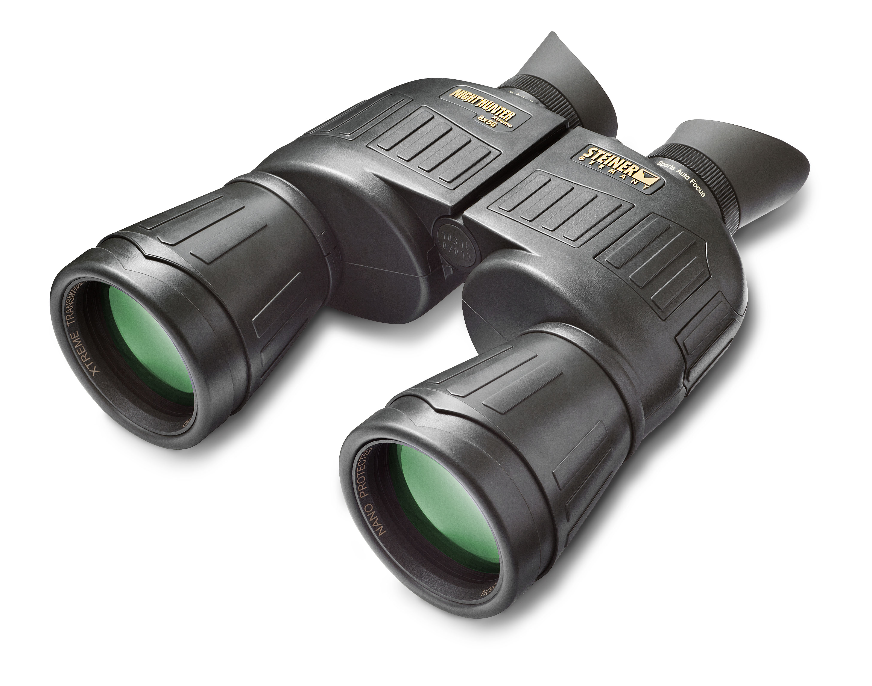

Headquartered in Bayreuth, Germany, Steiner-Optik has been widely acknowledged as a world leader in the manufacturing of high quality optics since 1947. In addition to the outdoor, hunting and marine markets, Steiner provides products to military and law enforcement worldwide. Allied forces around the world — including the U.S. Army and countless law enforcement agencies — have made Steiner their optics of choice. For more information contact: Steiner-Optik, 920 54th Avenue, Suite 200, Greeley, CO 80634; call (970) 356-1670 or toll free (888) 228-7747. Visit the company website at www.steiner-optics.com or Facebook page at www.facebook.com/SteinerOptics.

